Picture of Items | Name | Contents | Check Out Date/Availability

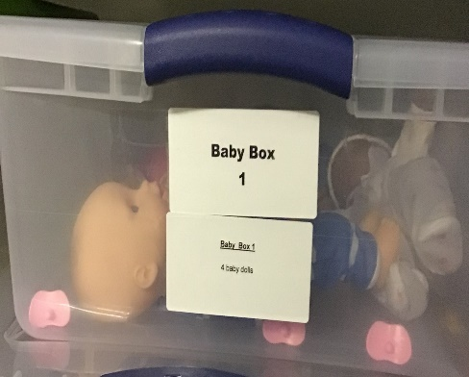 | Baby Box 1 | 4 Baby Dolls | Available

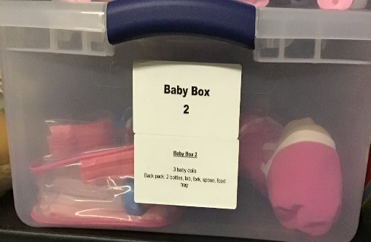 | Baby Box 2 | 3 Baby Dolls/Back pack:2 bottles, bib, fork, spoon, food tray | Available

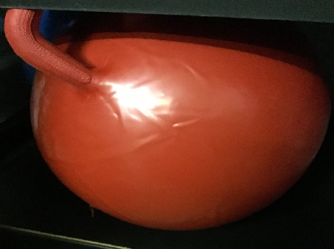 | Ball Hopper | Ball Hopper | Available

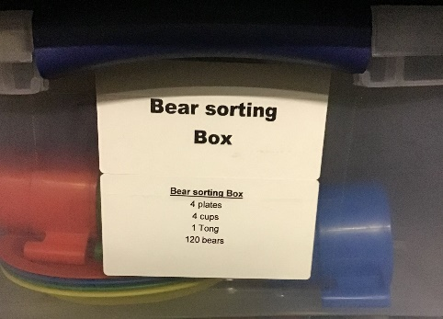 | Bear Sorting Box | 4 plates; 4 cups; 1 tong; 120 Bears | Available

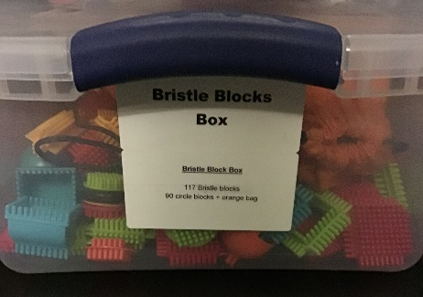 | Bristle Blocks Box | 117 Bristle Blocks; 90 Circle Blocks and Orange Bag | Available

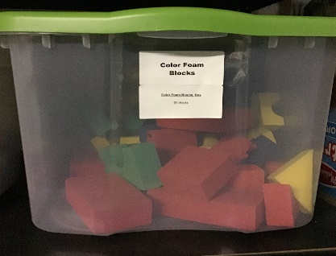 | Color Foam Blocks | 69 Color Foam Blocks | Available

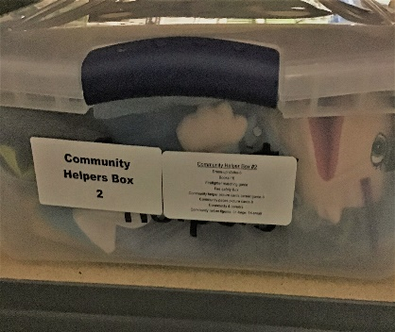 | Community Helpers Box 2 | Dress Up clothes – 5; Books – 16; Firefighter matching game; Community Helper Picture Cards Career Game; Community Places Picture Cards; Community Helper Figurines – 31 large and 14 small | Available

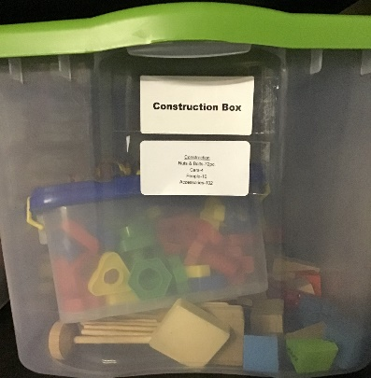 | Construction Box | Nuts and Bolts – 72 pieces; Cars – 4; People – 10; Accessories - 102 | Available

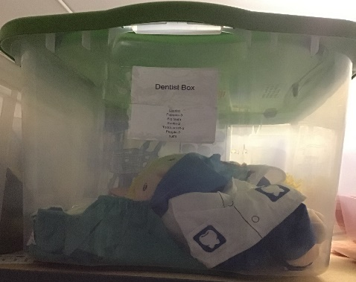 | Dentist Box | Puppets – 3; Big teeth; Books – 2; Tooth brush – 2; People – 3; Outfit | Available

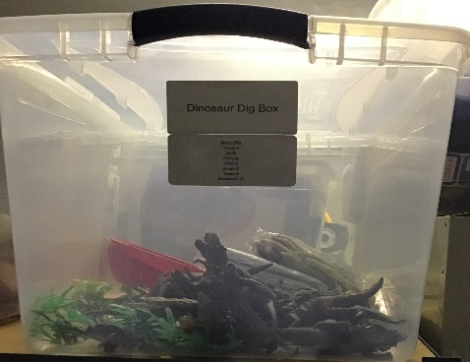 | Dinosaur Dig Box | Tongs – 2; Outfit; Felt rug; Sifter – 2; Brush- 3; Trees – 8; Dinosaurs - 12 | Available

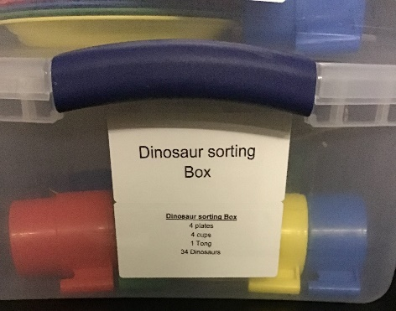 | Dinosaur Sorting Box | Plates – 4; Cups – 4; Tongs – 1; Dinosaurs - 34 | Available

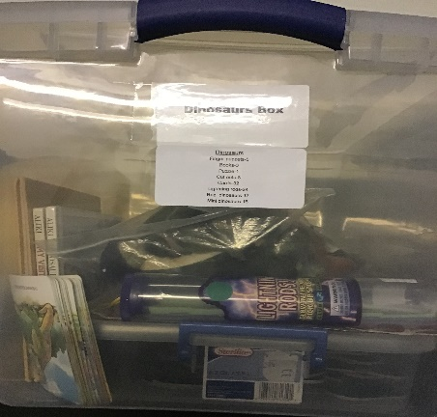 | Dinosaurs Box | Finger Puppets – 5  Books – 3  Puzzle – 1  Cut outs – 8  Cards – 32  Lightning Rods – 24  Reg. dinosaurs – 17  Mini dinosaurs - 16 | Available

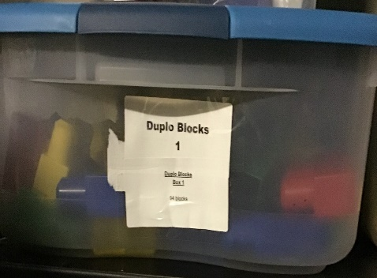 | Duplo Blocks Box 1 | Duplo Blocks – 94 blocks | Available

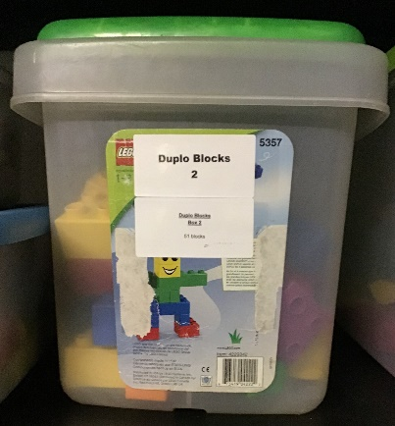 | Duplo Blocks Box 2 | Duplo Blocks – 51 blocks | Available

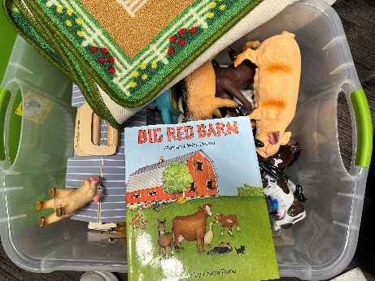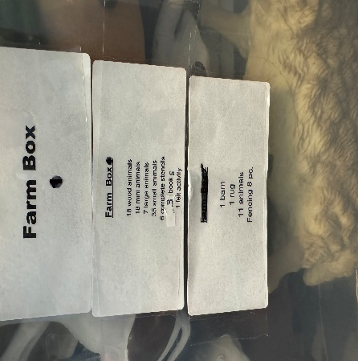 | Farm Box | Wood animals – 18  Mini Animals – 18  Large Animals – 7  Small Animals – 35 Complete Stencils – 6  Book - 3  Barn-1  Rug-1  Animals-11  Fencing-8 | Available

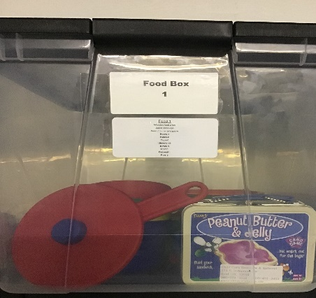 | Food Box 1 | Wooden Food – 21 pc  Wood crate – 4pc  Peanut Butter Jelly Game  Books – 3  Plates – 6  Cups – 6  Utensils – 26  Bowls – 4  Chef – 1  Oatmeal – 1  Pots – 2 | Available

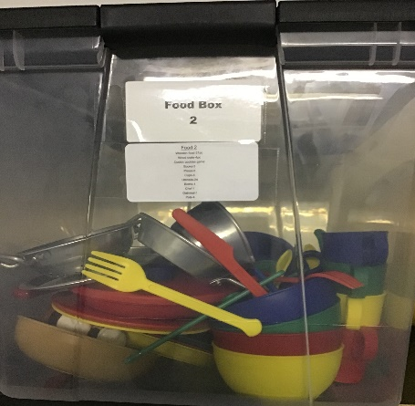 | Food Box 2 | Wooden Food – 21 pc  Wood crate – 4pc  Cookin’ Cookies Game  Books – 3  Plates – 6  Cups – 6  Utensils – 24  Bowls – 4  Chef – 1  Oatmeal – 1  Pots – 4 | Available

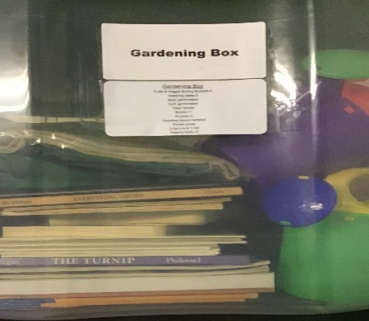 | Gardening Box | Fruit & Veggie Sorting Buckets - | Available

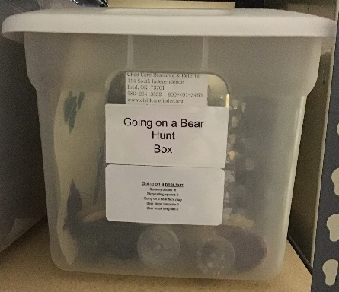 | Going on a Bear Hunt Box | Sensory Bottles – 6  Storytelling Spoons – 6  Going on a Bear Hunt Map  Bear Bingo Template – 2  Bear Mask Template – 2 | Available

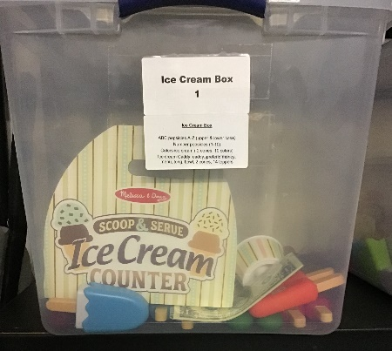 | Ice Cream Box 1 | ABC Popsicles A-Z (upper and lower case)  Number Popsicles (1-10)  Colors ice cream (2 cones, 10 colors) | Available

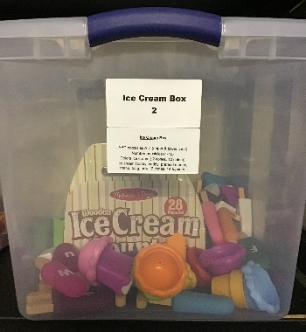 | Ice Cream Box 2 | ABC Popsicles A-Z (upper and lower case)  Number Popsicles (1-10)  Colors ice cream (2 cones, 10 colors)  Ice cream caddy: caddy, pretend money, menu, tong, bowl, 2 cones, 14 toppers | Available

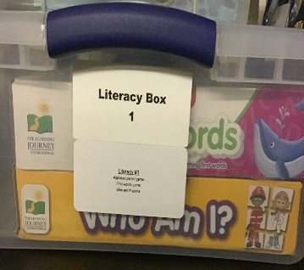 | Literacy Box 1 | Alphabet paired game  First words game  Who am I? game | Available

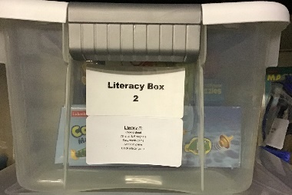 | Literacy Box | Cookie Sheet  78 letter and # magnets  Easy words game  Alphabet game  Catch a letter game | Available

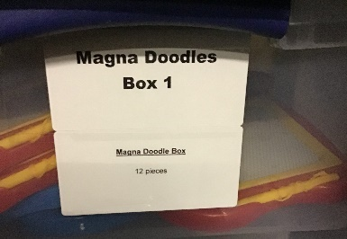 | Magna Doodles Box 1 | 12 Pieces | Available

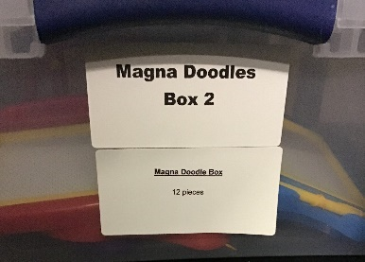 | Magna Doodles Box 2 | 12 Pieces | Available

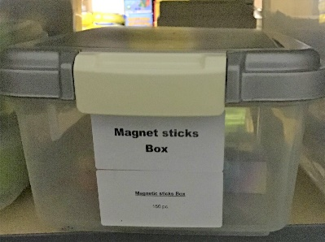 | Magnet Sticks Box | 150 Pieces | Available

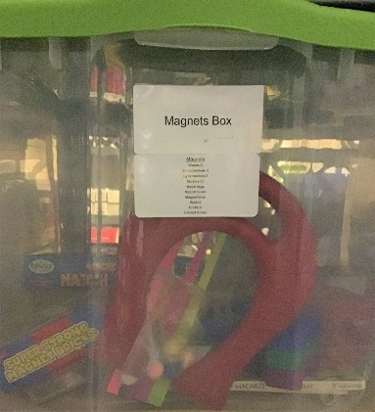 | Magnets Box | Wands – 3  Sm horseshoe – 5  Lg horseshoe – 2  Marbles – 12  Match rings  Magnet board  Magnet force  Books – 3  Bricks – 9  Colored lenses | Available

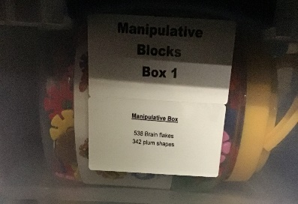 | Manipulative Blocks Box 1 | 538 Brain Flakes  342 Plum Shapes | Available

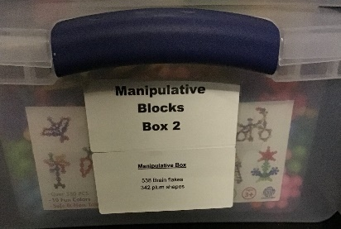 | Manipulative Blocks Box 2 | 538 Brain Flakes  342 Plum Shapes | Available

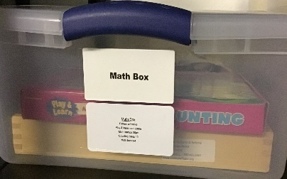 | Math Box | Pattern w/blocks  Play & learn math game  Math stamps 30 pc  Counting Cards – 10  Math books – 4 | Available

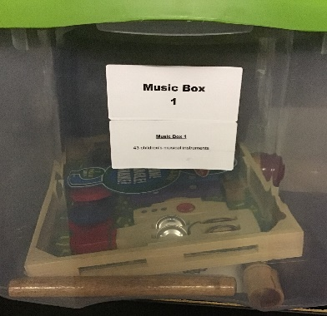 | Music Box 1 | 43 children’s musical instruments | Available

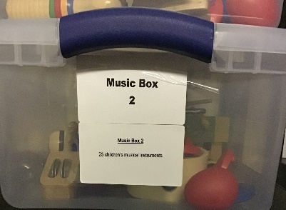 | Music Box 2 | 25 children’s musical instruments | Available

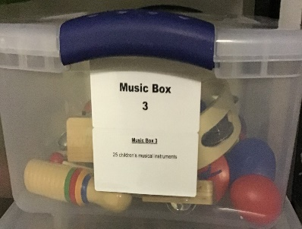 | Music Box 3 | 25 children’s musical instruments | Available

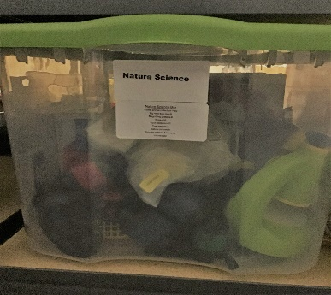 | Nature Science Box | Forest animal collection – 16 pc  Big view bug jars – 6  Magnifying glasses – 3  Books – 16  Rock collection- 12  Tree stencils – 6  Nature pictures – 8  Pictures of trees and leaves  Microscope | Available

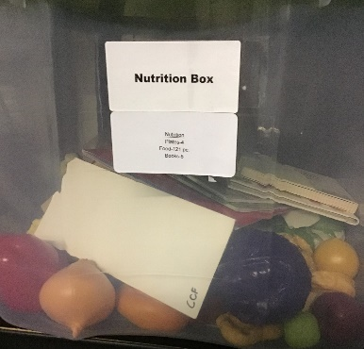 | Nutrition Box | Plates – 4  Food – 121 pc  Books – 5 | Available

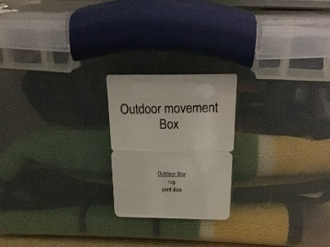 | Outdoor Movement Box | Rug  Yard dice | Available

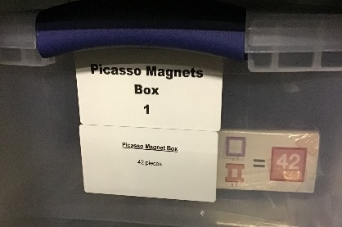 | Picasso Magnets Box 1 | 42 pieces | Available

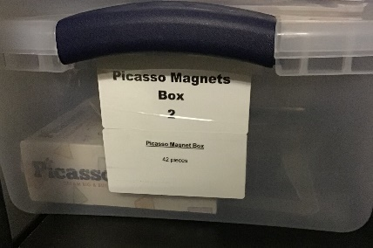 | Picasso Magnets Box 2 | 42 pieces | Available

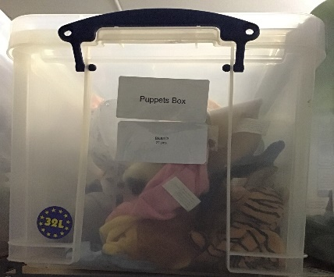 | Puppets Box | 21 pieces | Available

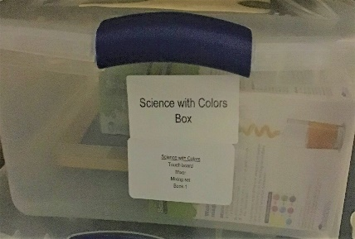 | Science with Colors Box | Touch board  Mixer  Mixing Set  Book – 1 | Available

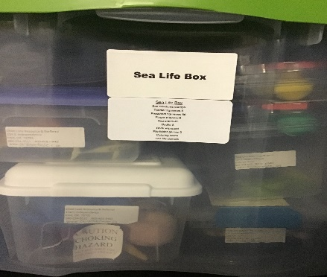 | Sea Life Box | Sea creatures stamps  Toddler figurines – 6  Preschool figurines – 56  Finger puppets – 8  Sea shells – 45  Books – 8  Book w/puppet  File folder games – 3  Coloring cards  Sea life stencils | Available

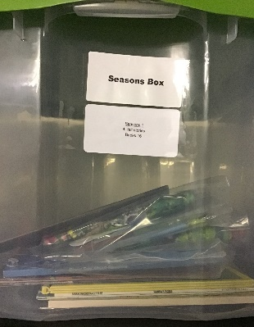 | Seasons Box 1 | 4 felt stories  Books – 16 | Available

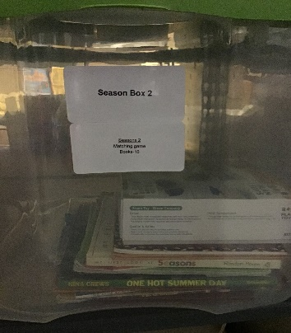 | Seasons Box 2 | Matching game  Books – 16 | Available

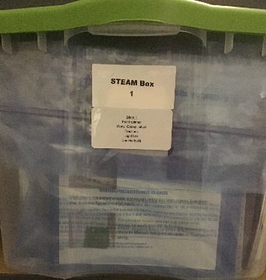 | Steam Box 1 | Paint spinner  Ooey, gooey, oil art  Fractions  Light Box  Domino Build | Available

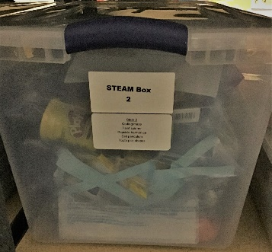 | Steam Box 2 |  | Available

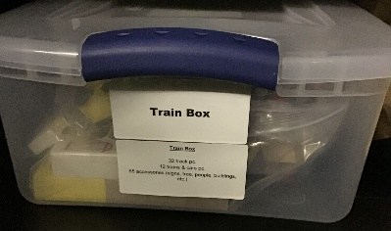 | Train Box |  | Available

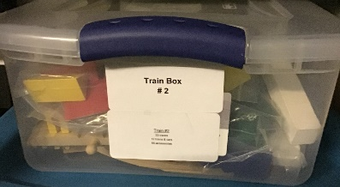 | Train Box 2 |  | Available

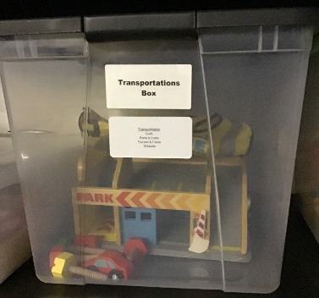 | Transportation Box |  | Available

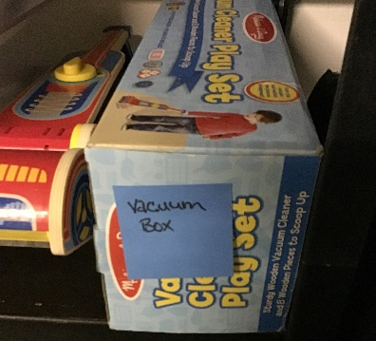 | Vacuum Box |  | Available

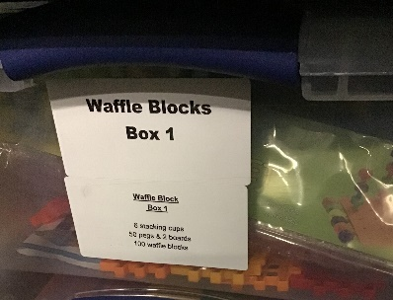 | Waffle Blocks Box 1 |  | Available

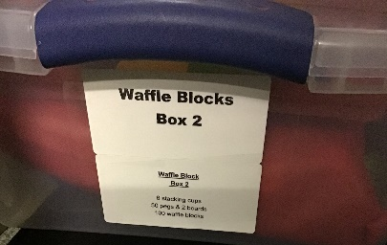 | Waffle Blocks Box 2 |  | Available

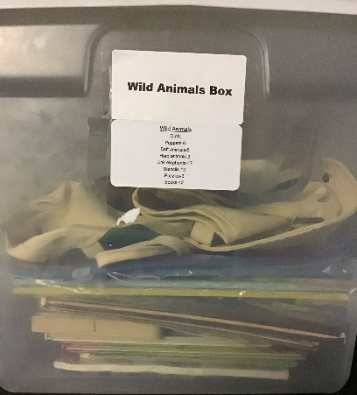 | Wild Animals Box |  | Available

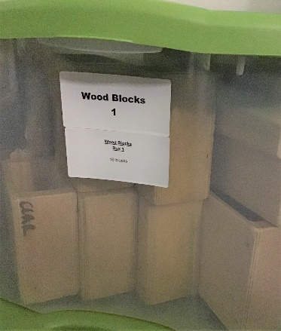 | Wood Blocks 1 |  | Available

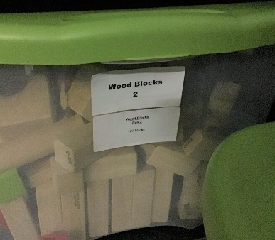 | Wood Blocks 2 |  | Available

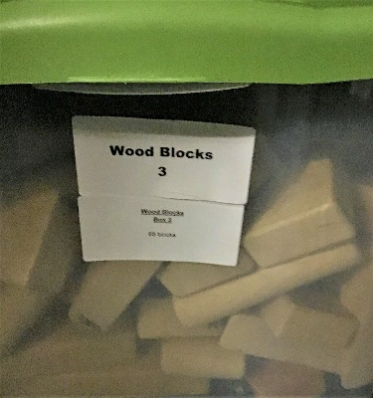 | Wood Blocks 3 |  | Available

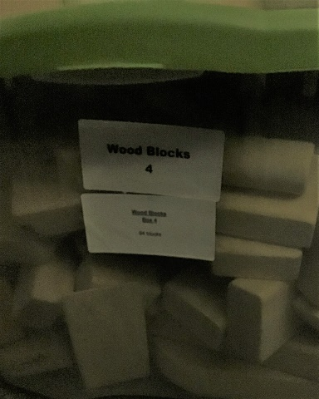 | Wood Blocks 4 |  | Available

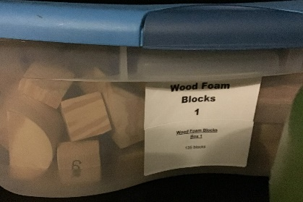 | Wood Foam Blocks 1 |  | Available

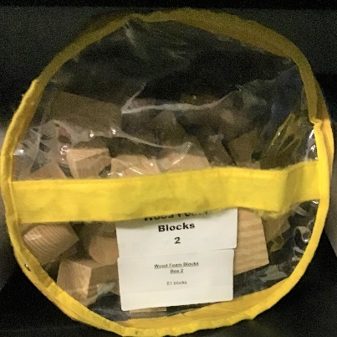 | Wood Foam Blocks 2 |  | Katie Endres checked out

